Simple Machines Packet
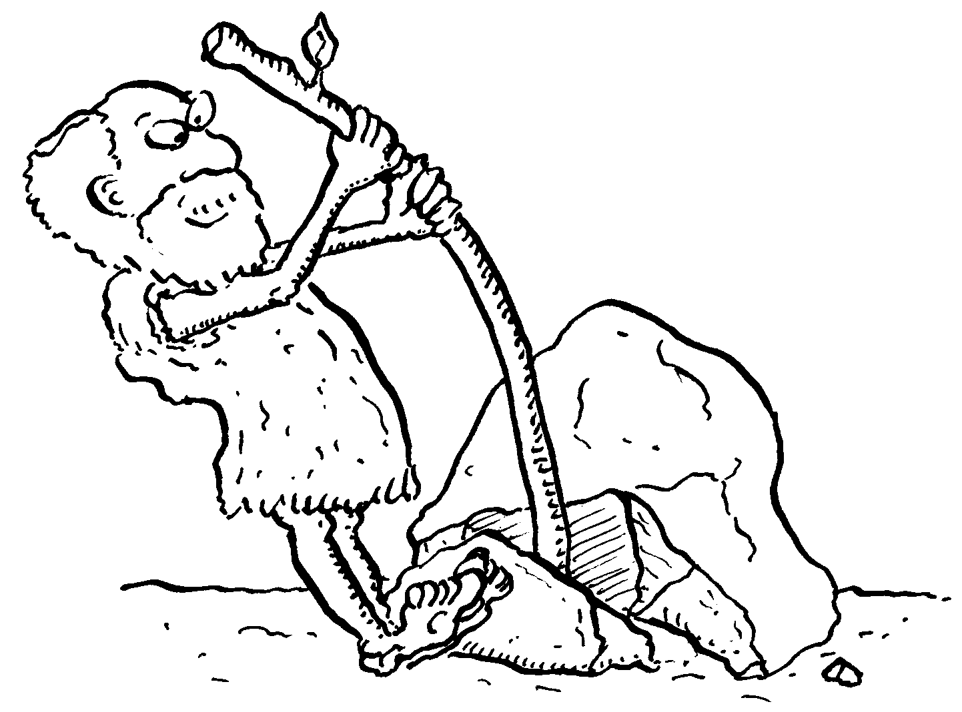
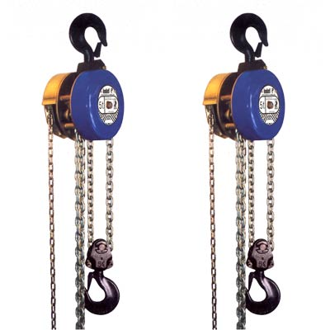

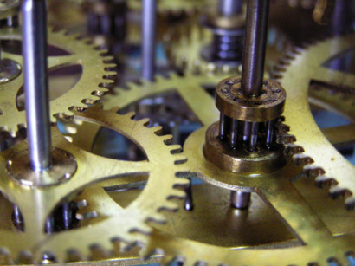
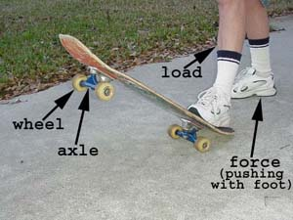
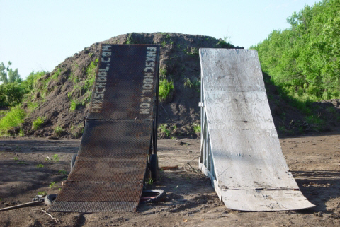
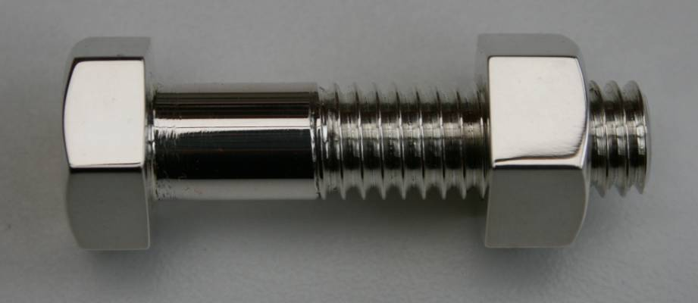
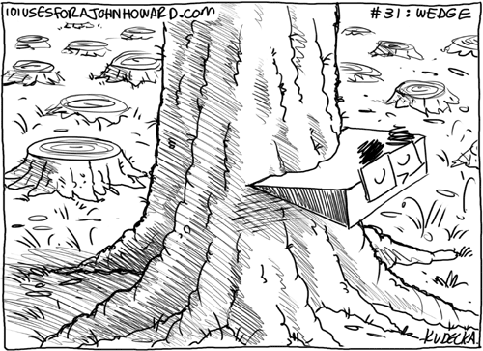
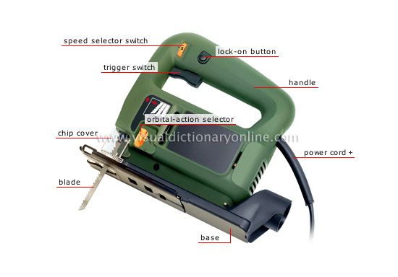

Introduction to Simple Machines

There are two groups of simple machines: levers and inclined planes.
Levers include:
- Levers
- Pulleys
- Wheels
- Axles
Inclined planes include:
- Ramps
- Wedges
- Threaded Objects
- Cutting Tools
Simple machines are designed to:
- Make work easier
- Change the direction of movement
- Make work faster

Levers

Fulcrum: The point around which a lever moves.
Effort: The force exerted by the machine. It is usually exerted at the handle by the user.
Resistance: The force which the lever tries to overcome.

There are three classes of levers: First Class, Second Class, and Third Class. How you can tell what is what kind of lever is by which part of the lever is in the middle like this:
First Class Lever: Fulcrum in the middle.
Second Class Lever: Resistance in the middle.
Third Class Lever: Effort in the middle.

Things I learned:
- What a fulcrum is.
- What the effort in a lever is.
- What the resistance in a lever is.
- Scissors are an example of a first class lever.
- A wheelbarrow is an example of a second class lever.
- A pair of tweezers is an example of a third class lever.
- There are three parts of a lever.
- Simple machines help with three things.
- One of those things is making work easier.
- One of those things is changing the direction of the force, so instead of pushing up on something, you push down so that gravity helps you.
- An example of this is a car jack.
- The third thing that simple machines help with is making work faster.
- There are three classes of levers.
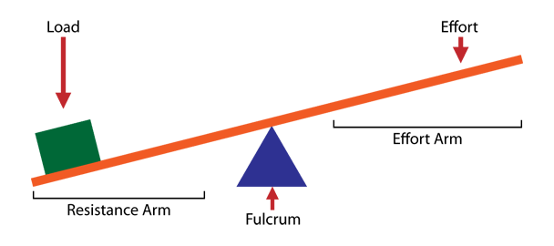

Levers Continued

Mr. Smith jammed a one-pound stapler onto the end of a meter stick. He then put the middle of the meter stick on the edge of the table. He exerted one pound of downward force onto the meter stick and the stapler raised in the air on the other end of the stick. He then moved the meter stick so that three-quarters of it was off the table, and the quarter with the stapler on it was on the table. He then exerted half a pound of force on the end of the meter stick, and raised the one pound stapler into the air. Then he moved the meter stick so that almost all of it was on the table, and only a few inches were off the table. He exerted ten pounds of pressure onto the meter stick and it raised into the air. He moved the meter stick so that there was only about an inch off the table, and then exerted twenty pounds of force onto the end of the meter stick, and raised the stapler into the air. This demonstration demonstrated the most important theory of simple machines: mechanical advantage. The first time Mr. Smith pressed down on the end of the meter stick, he had a mechanical advantage of one, or no mechanical advantage. This means that if you put the fulcrum of a lever exactly in the middle of the effort and the resistance, your mechanical advantage is one, or no mechanical advantage. The second time he pressed down, his mechanical advantage was two. The third time his mechanical advantage was .1, and the last time his mechanical advantage was .05. This shows that the closer the fulcrum is to the resistance, the more mechanical advantage you have. The equation for figuring out mechanical advantage is:
MA = EF / RF
^{level}
This means Mechanical Advantage equals the distance between Effort and Fulcrum divided by the distance from Resistance to Fulcrum.
Here is a table showing the different mechanical advantages that Mr. Smith used:
Number of times easier
Apparent Weight or harder Relation to one
1 pound stapler | MA = 1 | MA = 1
1/2 pound stapler | MA = 2 | MA > 1
10 pound stapler | MA = .1 | MA < 1
20 pound stapler | MA = .05 | MA < 1

A good way of remembering the different classes of levers is to think:
F is the first letter of the word free, and is the first letter of fulcrum, which is in the middle for a first class lever.
R is the second letter of the word free, and is the first letter of resistance, which is in the middle for a second class lever.
E is the third letter of the word free, and is the first letter of effort, and the effort is in the middle for a third class lever.
If you add an E, all these letters spell out the word FREE.
F
R
E
E

Things I learned:
- First class levers always have the fulcrum in the middle.
- First class levers always change the direction of the force.
- First class levers always make work easier.
- First class levers are used for speed.
- An example of a first class lever is the rope on a flagpole, which changes the direction of the force.

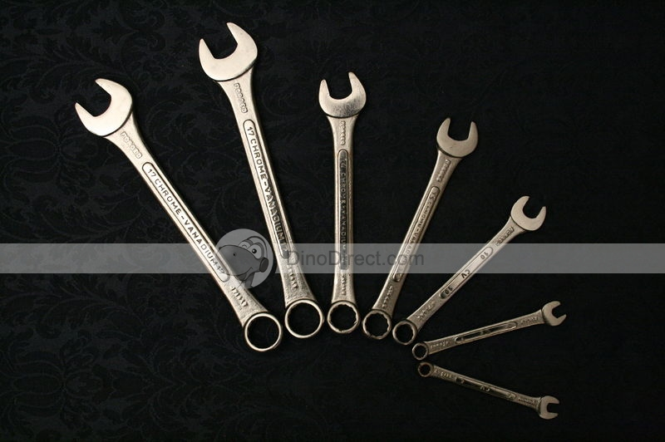

Second Class Levers

- Always make work easier.
- Mechanical advantage is always greater than one.
- The distance from the effort to the fulcrum is always greater than the distance from the resistance to the fulcrum.

Mr. Smith did a demonstration where he used a pair of tin snips or a shear to cut a penny in half. He put the penny right near the fulcrum, because the closer the resistance is to the fulcrum, the easier it is. He slowly closed the tin snips, and at the end he had a neatly cut in half penny. The reason he was able to do this is because pennies are made out of zinc, which is a very soft, very cheap metal. He could do this very easily, because since the distance from the effort to the fulcrum was fifteen centimeters, and the distance from the resistance to the fulcrum was two centimeters, and MA = EF / RF, his mechanical advantage was 7.5.

Things I learned:
- Pennies are made out of zinc, not copper. They are just coated in copper to make it look like they are made out of copper.
- Tin snips can also be called a shear.
- The smaller the denominator is in a fraction, the bigger overall the fraction is.
- For a second class lever, you want the distance from the resistance to the fulcrum to be as small as possible, because since MA = EF / RF, and since the smaller the denominator of a fraction is, the bigger overall the fraction is, that makes your mechanical advantage larger.
- Tin snips are sometimes used for cutting sheet metal, such as old license plates.

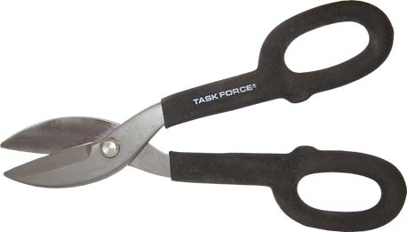

Third Class Levers

Today Mr. Smith did a demonstration with a third class lever. He taped two meter sticks together to make a giant pair of tweezers. He then had you put your hands in between the arms of the tweezers, and squeezed as hard as he could. It didn't hurt at all, because the distance from the effort to the fulcrum was way less than the distance from the resistance to the fulcrum. This is why third class levers are never used for power.

Things I learned:
- Third class levers are never used for power.
- Third class levers are used for speed.
- Third class levers always have a mechanical advantage of less than one.
- On a third class lever, the distance from the effort to the fulcrum is always less than the distance from the resistance to the fulcrum.
- Tweezers are a third class lever.
- Our bodies have lots of third class levers in them.
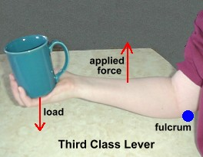
Pulleys

Mr. Smith showed us how fixed and moveable pulleys work. He hung a pulley from a rope on the ceiling, and then put a rope through the pulley. He then hung a .5 kilogram weight on either end of the rope. He let go, and instead of moving, the weights stayed at exactly the same height off the ground as before. They were perfectly balanced. He then put a moveable pulley on the rope strung from the fixed pulley, and hung one of the .5 kilogram weights on a rope hanging from that instead. He let go, and the weight attached to the moveable pulley went up, and the one on the other end of the rope went down. This is because the moveable pulley gave the weight that wasn't hung from it a mechanical advantage of 2. He then hung another .5 kilogram weight from the rope on the moveable pulley, let go, and they stayed perfectly balanced, since one of the three weights had a mechanical advantage of 2, and there were 2 weights on the other end.

Things I learned:
- There are two kinds of pulleys: fixed and moveable.
- Any pulley can be either kind, it just depends on how you use it.
- A fixed pulley acts like a first class lever.
- A fixed pulley changes the direction of the force.
- A fixed pulley has a mechanical advantage of 1.
- A moveable pulley acts like a second class lever.
- A moveable pulley has a mechanical advantage of 2.
- A fixed pulley stays in place; only the wheel turns.
- A moveable pulley can swing.
- Some of the words that people used to describe the feeling of pulling on the perfectly balanced weights on the pulley: weightless, smooth, weird, cool, awesome, balanced.

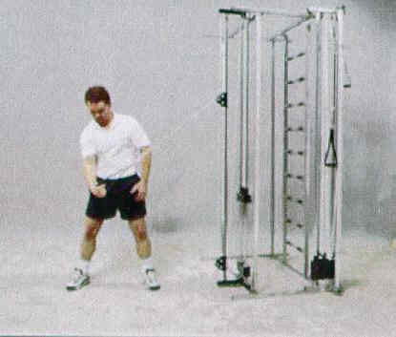
R2-D3

R2-D3 mad an appearance in class. He is R2-D2's extremely overweight cousin. He weighs over 300 pounds and will chop your toes off if you stand underneath him. Mr. Smith lifted him off the ground using four pulleys: two fixed and two moveable.

Things I learned:
- R2-D2 has a cousin.
- If you have four pulleys, two moveable and two fixed, then you have mechanical advantage of 4 to 1.
- This means lifting 300 pound R2-D3 was like lifting something that weighed seventy-five pounds.
- This trades speed for power.
- That means that it takes 4 times longer to lift R2-D3, but it makes up for it by being 4 times easier.
- If you rigged it so that the mechanical advantage was 1 to 4, it would be 4 times faster but it would also be 4 times harder.
- In that case, you would be trading power for speed.
- A pulley system can be called a block and tackle.
- Block is an old-fashioned way of saying pulley.
- Tackle is another way of saying "gear", such as "fishing tackle."
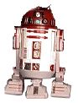
Great Fall

In class today, Mr. Smith did a demonstration to show us how much easier pulleys can make things. He attached a fixed pulley to the ceiling, attached a moveable pulley to the fixed one, and put a rope through both of them twice. He then tied our feet together, attached a hook on the end of the moveable pulley to the rope on our feet, and had us haul ourselves up the rope. It was really easy! He then let us swing from side to side, and gave us two choices about how to come down: slowly lowered down, or the great fall where he would measure out a certain amount of rope, hold on to the end of where he measured, and let go of the rope. He would stop you about a foot from the floor.

Things I learned:
- Friction is resistance.
- The less friction there is, the easier everything is.
- For example, if the ropes were rubbing together, then it would be harder to pull yourself up.
- Friction decreases mechanical advantage.
- It was surprisingly easy to pull yourself up.
- The great fall was really fun!
- This hurt your ankles.
- Swinging from side to side on the end of a rope hanging from the ceiling is really fun!
- Everyone's faces turned red when they were hanging upside down.
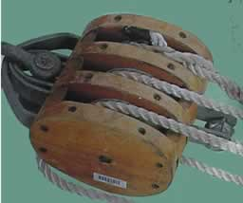
- It was the strangest thing I've ever seen in a classroom.

Gears

Today Mr. Smith taught us about gears.

Things I learned:
- Gears act like first class levers.
- The drive gear is the gear to which the effort is applied.
- The driven gear has the resistance.
- The formula for figuring out mechanical advantage of gears is MA = Number of teeth on drive gear / Number of teeth on the driven gear.
- A mechanical advantage of > 1 = power.
- A mechanical advantage of < 1 = speed.
- If you have a large back gear and a small front gear you get power, such as on a bike. The largest back gear is the easiest and the smallest front gear is the easiest.
- If you have a small back gear and a large front gear you get speed, such as on a bike. The smallest back gear is the hardest and the largest front gear is the hardest.
- The gears go the opposite direction of the gear turning them. So if you had the drive gear going clockwise, then the first driven gear would go counterclockwise, and the second gear would go clockwise, and so on.
- A sprocket and a chain equal a gear.
- A bike is a sprocket and chain kind of gear.
- The sprockets on a sprocket and chain gear go the same direction.
- The shifter on a standard transmission car has lots of gears in it.
- It has one for neutral, first gear, second gear, third gear, and reverse.
- The shifter on a standard transmission is called a stick shift or a column shift.
- When you turn on a standard transmission car on it is in first gear.
- In first gear you want more power than speed, and the mechanical advantage is 2.75:1.
- In second gear the mechanical advantage is 1.75:1.
- In third gear the mechanical advantage is 1:1.
- In reverse the mechanical advantage is 2.90:1.
- The shifter pattern is an "H."
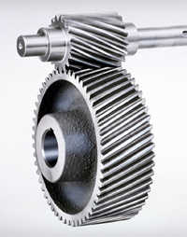
Wheels and Axles

Today in Science class, Mr. Smith taught us about wheels and axles.

Things I learned:
- A wheel and axle act like a first class lever.
- Doorknobs are wheel and axles.
- Round handles are wheel and axles.
- Pulleys are wheel and axles.
- Gears are wheel and axles.
- Drive wheels are wheel and axles.
- Bill Nye the Science Guy teaches science.
- Mr. Smith doesn’t like Bill Nye the Science Guy.
- Wheel and axles are a kind of lever.
- Wheel and axles are a simple machine.

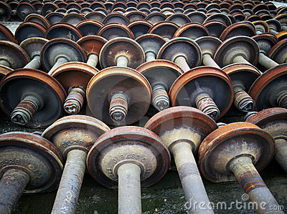

Ramps

Mr. Smith taught us about ramps today in Science class.

Here are some of the things I learned:
- Inclined planes give mechanical advantage because of their shape.
- The mechanical advantage of a ramp is always > 1.
- Ramps always make work easier.
- Ramps give mechanical advantage because they are longer then they are high.
- The formula for figuring out the mechanical advantage of ramps is MA = Length of ramp divided by Height of ramp.
- Stairs are a kind of ramp.
- If you have a ramp that is 182 inches long and 23 inches high, the mechanical advantage is 7.91.
- If you have a ramp that is 182 inches long and 52 inches high, the mechanical advantage is 3.5.
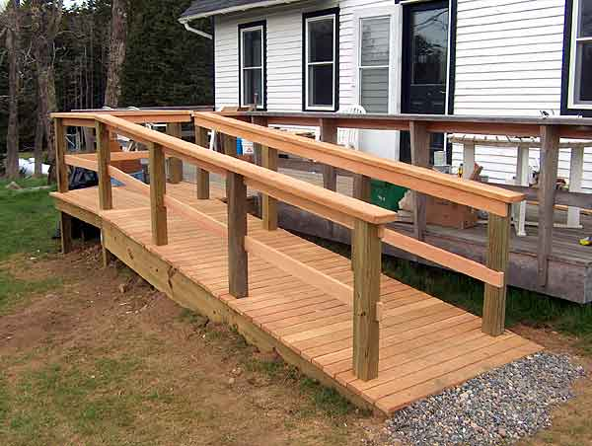
Threaded Objects

Today in Science class, Mr. Smith taught us about threaded objects.

Things I learned:
- Threaded objects are a kind of inclined plane.
- Threaded objects are a kind of simple machine.
- The formula for determining the mechanical advantage of a threaded object is the same as for a ramp.
- You have to figure out mathematically how long the threads are, and use that as your length.
- The more threads there are per inch the higher the mechanical advantage is.
- A thread is a spiral ridge running continuously around a bolt, screw nut augur or gear.
- A spiral staircase is sort of like a threaded object, just much, much bigger.
- A bolt is a kind of threaded object.
- A screw is a kind of threaded object.
- An augur is a kind of threaded object.

Wedges

Today in Science class Mr. Smith taught us about wedges.

Some of the things I learned are:
- A wedge is an inclined plane.
- A wedge is a kind of simple machine.
- Wedges give mechanical advantage because of their shape.
- A wedge is an inclined plane for changing the direction of the force.
- The formula for determining mechanical advantage of wedges is:
MA= Length of Wedge divided by Width of Wedge
- A wood splitting wedge is a kind of wedge.
- The triangular blocks that you put behind car tires to prevent them from rolling are wedges.
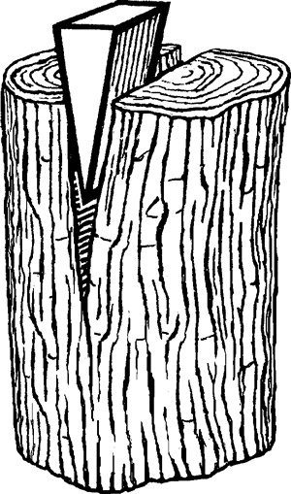
Cutting Tools

Today in Science class, Mr. Smith taught us about cutting tools.

Here are some of the things I learned:
- Cutting tools are inclined planes that give mechanical advantage because of their shape.
- A saw is a cutting tool.
- A carpentry plane is a cutting tool.
- A razor is a cutting tool.
- A razor is one of the cutting tools with the best mechanical advantage because of its tiny width.
- A come-along is a tool used for giving huge mechanical advantage.
- A come-along is a combination of pulleys, ratchets, and levers.
- The resistance on the lever part of the come-along is very close to the fulcrum, which gives it higher mechanical advantage.
- You can lift something that weighs 300 pounds with your pinky using a come-along.
- The round things on top of telephone poles are called transformers.
- They have about a mile of copper wire inside of them.
- The distance between the threads of a threaded object is called pitch.
Simple Machines Vocabulary

Simple Machines
Fulcrum
Effort
Resistance
Block and Tackle
Thread
Wedge
Come-Along
Inclined Plane

